Nathan Bemus

Digital Image Processing

ECCS 4361

9/13/17

Task 1:

This is the image that has the low brightness and bad contrast.

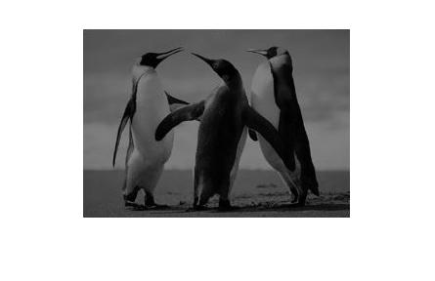 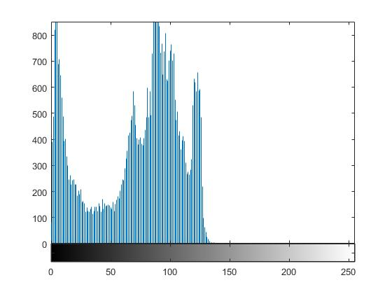

The following Matlab code was used to find both the mean and standard deviation of the image.

std(std(double(I)));

imshow(I);

mean(mean(double(I)));

std(std(double(I)));

S = std(std(double(I)));

M = mean(mean(double(I)));

imhist(I);

histeq(I);

figure(2), imshow(I);

This is the image after the Matlab code.

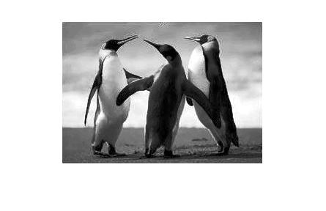 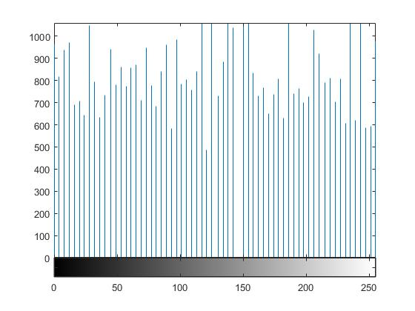

>> im = imread('Grayscale Penguin', 'jpg');

>> im=rgb2gray(im);

>> x = std(std(double(im)));

>> y = mean(mean(double(im)));

>> steps = (0:1:255);

>> z = (1 ./ (sqrt(2 .\* pi) .\* x )) .\* exp(-0.5 .\* ((steps - y) ./ x) .^ 2);

>> im2 = histeq(im, z);

Task 2:

I used the following image and used the following matlab code to make the “tiled” image. The first image is the original and the image under the code is the “tiled” image.

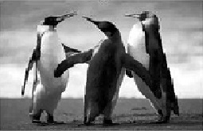

imMatrix =zeros (495, 765);

imMatrix(166:330 , 256:510) = im;

imMatrix(166:330 , 511:765) = im(165:-1:1 , 1:255);

imMatrix(166:330 , 511:765) = im(1:165 , 255:-1:1);

imshow(imMatrix);

>> imMatrix(166:330 , 1:255) = im(1:165 , 255:-1:1);

>> imshow(imMatrix);

>> imMatrix(1:165 , :) = imMatrix(330:-1:166 , :);

>> imshow(imMatrix);

>> imMatrix(331:495 , :) = imMatrix(330:-1:166 , :);

>> imshow(imMatrix);

>> imshow(imMatrix/max(max(imMatrix)),[0,1]);

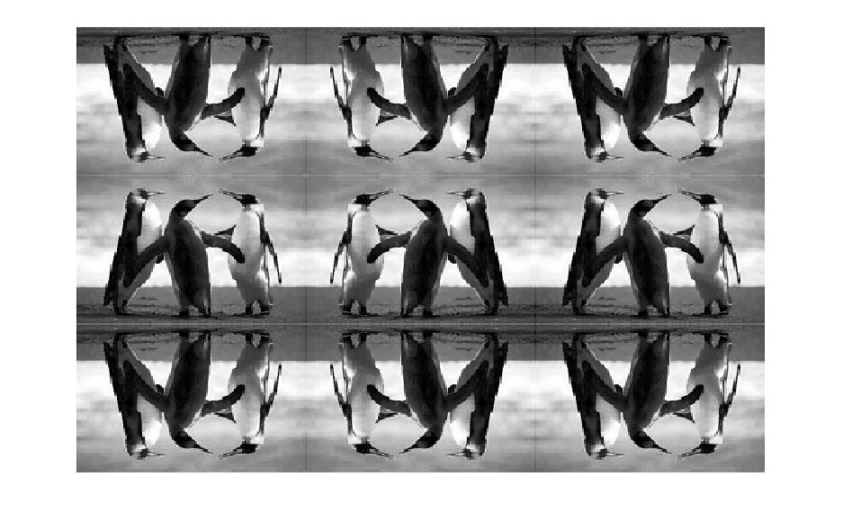

I was unfortunately unable to get the second half of this task to work properly in matlab.